A REPORT

ON

**ENGINE EMISSIONS CALIBRATION**

BY

K.BADARI VISHAL

B.E.(Hons.) Mechanical

BITS Pilani, K.K.Birla Goa Campus

2018 – 2022

AT

**ReynLab – Sirius Motorsports Pvt. Ltd.**

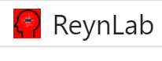



**June - November, 2020**

A REPORT

ON

**ENGINE EMISSIONS CALIBRATION**

BY

K.BADARI VISHAL

B.E.(Hons.) Mechanical

BITS Pilani, K.K.Birla Goa Campus

2018 – 2022

AT

**ReynLab – Sirius Motorsports Pvt. Ltd.**





**June - November, 2020**

**ReynLab Internship**

**Station:** Sirius Motorsports Pvt. Ltd. **Mode:** Virtual

**Duration:** 5 months **Date of Start:** June 28th, 2020

**Date of Submission:** November, 2020

**Title of the Project:** Engine Emissions calibration

**Name Discipline**

K.BADARI VISHAL B.E. (Hons) Mechanical, BITS Pilani Goa Campus

**Name of Mentors:** Mr. Sajeeth Kumar (Founder & CEO), Mr. Akhil.

**Keywords:** Engine emissions, Bench Marking, Calibration, Brake Torque, Spark Advance, AFR (Air fuel ratio)

**Abstract:** This report is prepared based on the Internship work performed ReynLab, Sirius Motorsports Pvt. Ltd. This report discusses the variation of emission constituents (NOx, CO and HC) along with varying throttle and spark advance. Simultaneously, Brake torque corresponding to these values of Emission constituents are obtained. The hierarchy followed is – Bench Marking, Calibration, and Validation. All data are extracted from ReynICE – a virtual engine test cell by ReynLab.

**TABLE OF CONTENTS**

1. *Cover Page* 1
2. *Title Page* 2
3. *Abstract* 3

1. Introduction 5

1.1 What are emissions? 5

1.2 HC & CO 5

1.3 NOx 5

2. Considerations 5

3. Bench Marking 6

4. Calibration 8

5. Conclusion 10

6. References 12

**1. Introduction**

**1.1 What are emissions?**

Emissions are basically the unwanted by-products of the combustion processes. They are of following kinds – HC, NOx, CO, SOx, PM, SOC, CO2. Our study interests over finding emission percentages of ‘HC’, ‘CO’, and ‘NOx’.

**1.2 HC & CO**

* These are generally formed when there is an Oxygen deficiency
* Typically for Rich mixtures
* These emission constituents are also formed when mixtures are not homogeneous (or uniform)
* COs are basically odorless and are very harmful to humans
* HCs show their effects by forming ground level smog (petrochemical smog)

**1.3 NOx**

* These are formed when Nitrogen in air/fuel mixes with oxygen at high temperatures
* They are of three types is organized as such, namely – Thermal NOx, Fuel NOx and Prompt NOx
* Typically are produced in higher amounts for slightly lean mixtures
* NOxs affect by forming Acid rains

**2. Considerations**

* Engine RPM range: 4000 – 10000 RPM with increment of 1000 RPM
* Throttle range 4% - 100% with increment of 20%
* Spark advance values are kept default for Bench Marking
* AFR (Air-Fuel ratio): 12.5, 14.7, 15.5

**3. Bench Marking**

The objective of Bench Marking was to estimate the Brake Torque & Emission percentages of 'CO', 'HC' & 'NOx' for the considered Engine RPM range by varying the Throttle.

* Three cases are considered as depicted below:

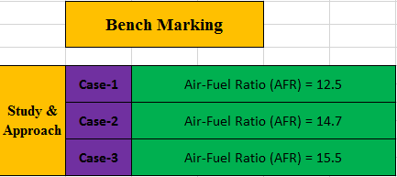

* Below tabulation shows the default Spark Advance values given for Bench Marking

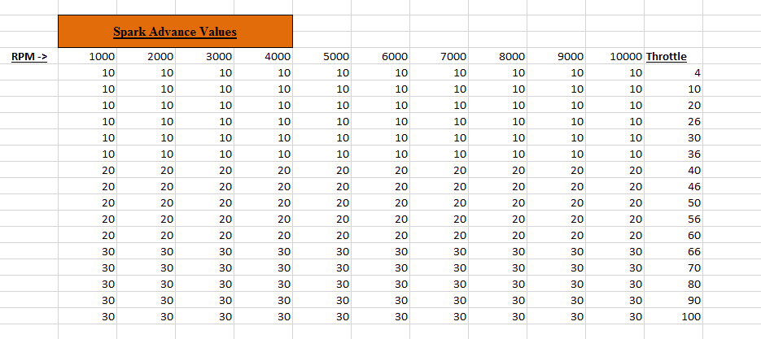

A sample graph of emission variations at 4000 RPM and 14.7 AFR is shown below:

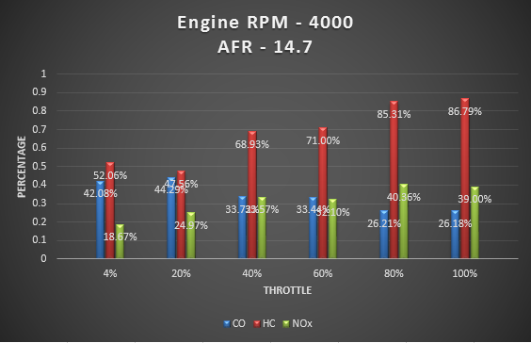

It’s corresponding data set is as follos:

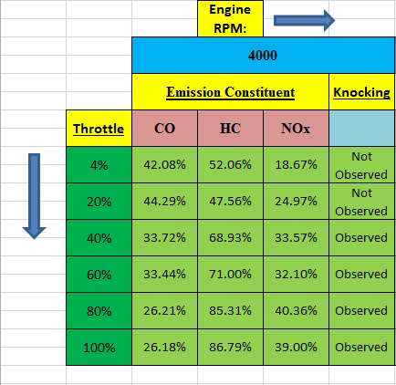

**4. Calibration**

Calibration involved following two objectives:

1. Finding Maximum Torque and corresponding NOx emission percentages at the given RPM range by varying spark advance values at AFR 14.7.
2. Finding Minimum NOx emmission percentages and corresponding Torque values at the given RPM range by varying spark advance values (For positive value of Torque) at AFR 14.7.

Spark Advance (SA) Tables for each case were found out to be as follows:

**Case - i**

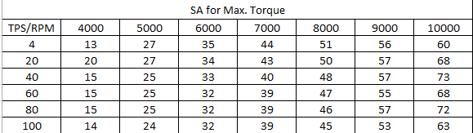

**Case – ii**

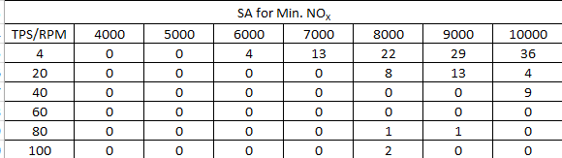

Graphs for variation of NOx emissions are plotted as follows:

**Case – i**

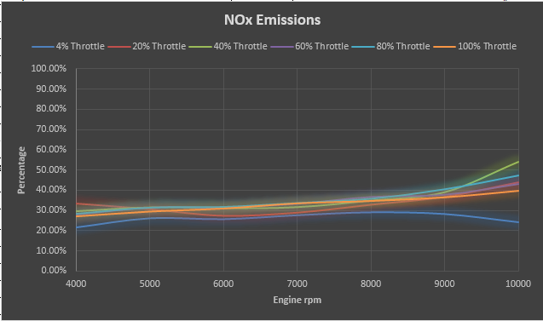

**Case – ii**

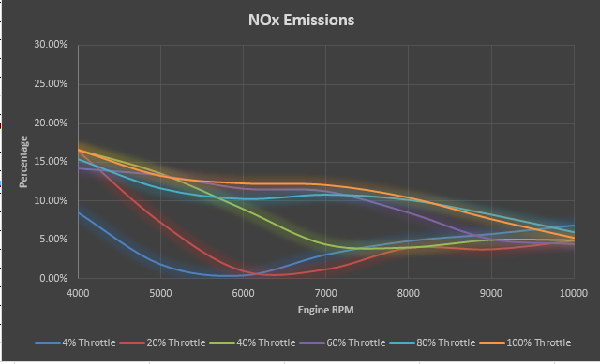

**5. Conclusion**

Emission constituents NOx, CO, and HC were taken into consideration and their respective emission percentages along with the Brake Torque were found out based on the data obtained from ReynICE – a virtual Engine test cell whose demo picture is shown as below:

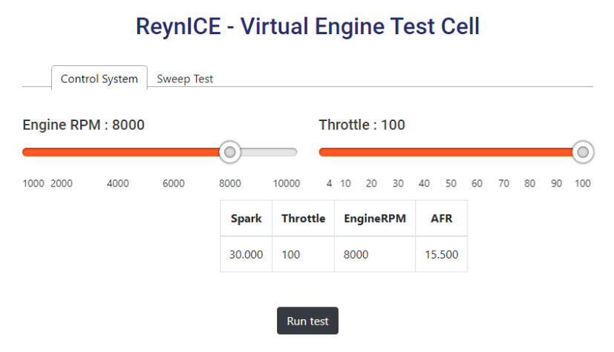

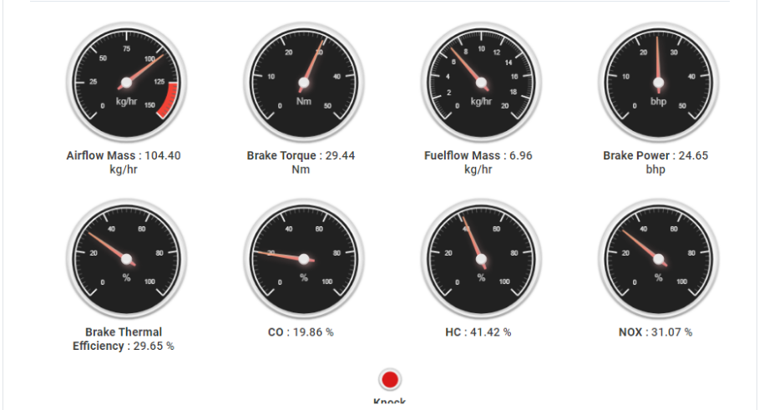

Possible variations of emissions with varying AFR values would give us following graphical outputs:

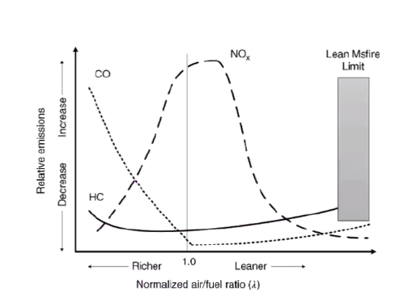

The above figure graphically visualizes the variation of CO, HC and NOx emission constituents with AFR values.

However, our objective was confined to how these emissions varied at given AFR values by varying only Throttle keeping Spark advance as constant in the case of Bench Marking.

As a part of Calibration, Spark advance along with Throttle were 2 parameters that were varied to estimate –

1. Maximum Torque and their corresponding NOx emission percentages
2. Minimum NOx emissions and their corresponding torque outputs

**6. References**

Here are some references graphs that were considered –

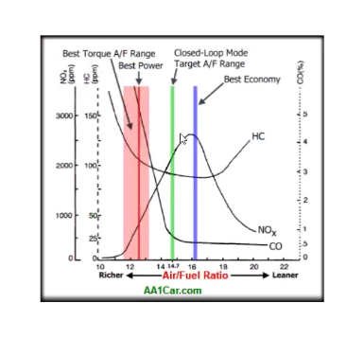

Books referred –

1. John Heywood, *Internal Combustion Engine Fundamentals*, 1998 edition.
2. V. Ganesan, *Internal Combustion Engines*, 4th edition – 2012.

All files available at: <https://github.com/vishalk2/Engine-Emissions-Calibration>